# 1.

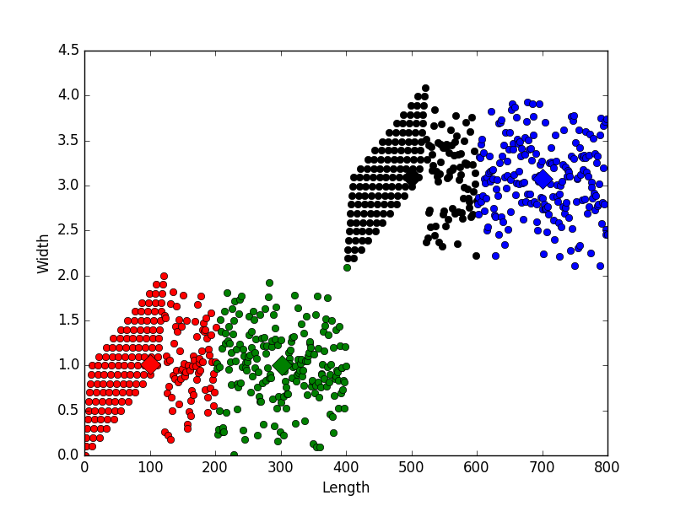

Finding:

1. The consequence changes every time.
2. Sequential versions of the k-means, where the updating of the representatives takes place immediately after the identification of the representative that lies closer to the current input vector xi, have also been proposed

# 2

1）

From 

2）train and test the data result：

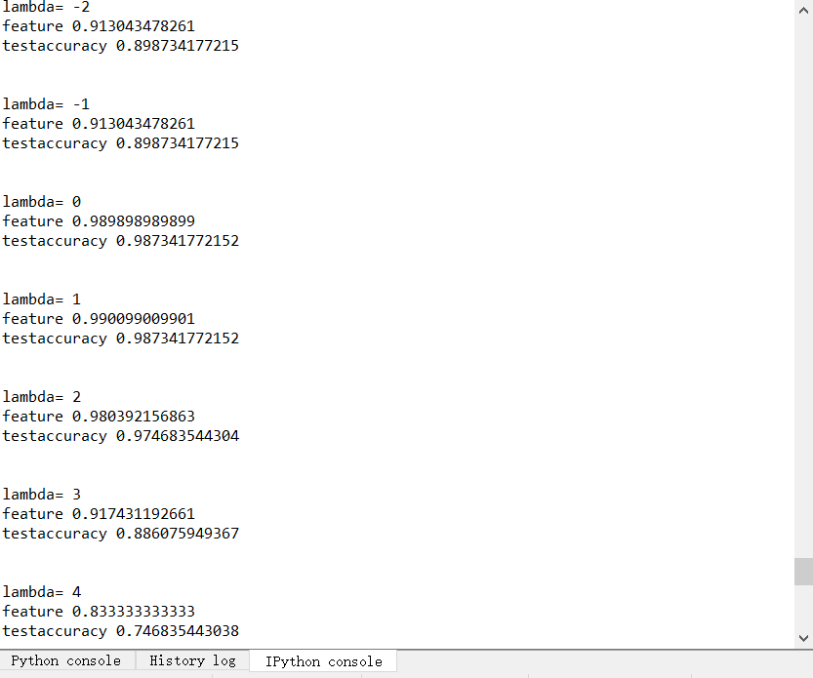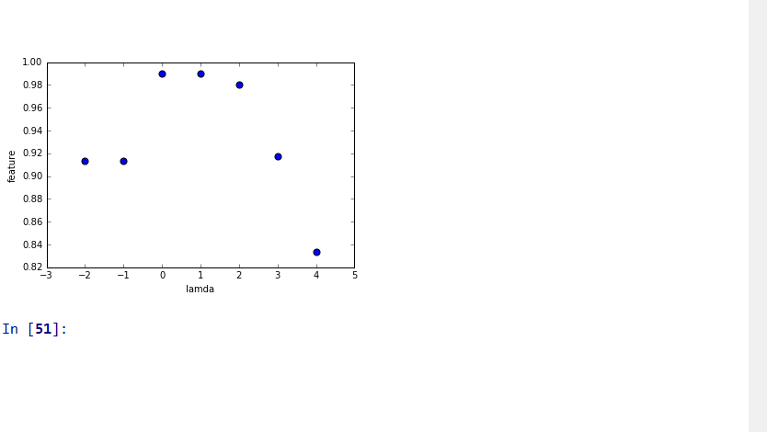

3)Train and test the data result with standardization protocol：

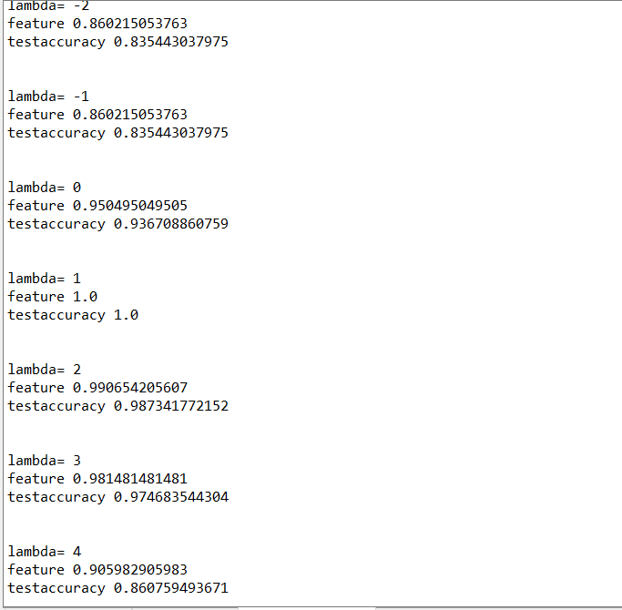

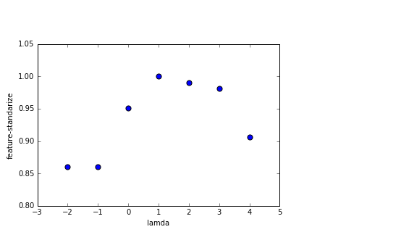

# 3

The result as follows:

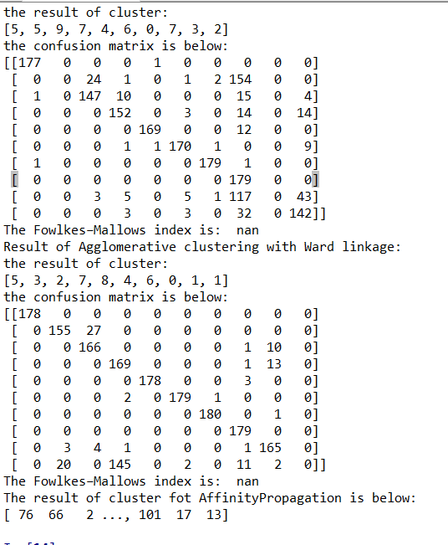

# 4.

The output of correctly Classified Instances of three algorithms:

